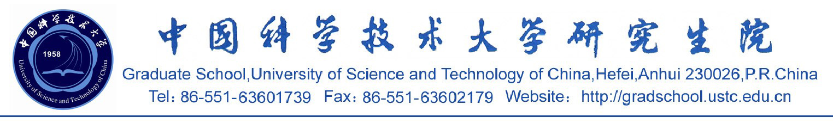

硕博连读生在读证明
XXX，男，生于1977年10月14日。现为中国科学技术大学计算机科学技术系计算机软件与理论专业在读博士生，2002年9月注册入学，学号为BA02011010。原为中国科学技术大学1996级本科生，于2000年免试推荐为硕博连读生。
特此证明。
中国科学技术大学研究生院
2005-4-29

Certification of Doctoral Student
This is to certify that Mr. XXXX, born on Oct. 14, 1977, is a doctoral student majoring in computer science at University of Science and Technology of China, and registered from Sept. 2002 to present with his student ID No. of BA02011010. He was an undergraduate of USTC from 1996 to 2000 and was admitted to Department of Computer Science of USTC in 2000 to study for a doctoral degree.
Graduate School
University of Science and Technology of China
04-29-2005

