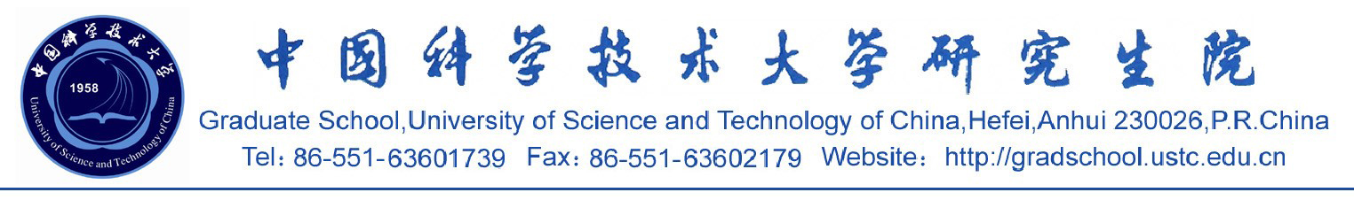

证 明
XXX，男，生于1977年10月14日。现为中国科学技术大学计算机科学技术系计算机软件与理论专业在读博士/硕士生，2002年9月注册入学，学号为BA02011010。
特此证明。
中国科学技术大学研究生院
2005-4-29

Certification
This is to certify that Mr. XXXX, born on Oct. 14th, 1977, is a doctoral student /master’s student majoring in computer science at University of Science and Technology of China from Sept. 2002 to present. His student ID No. is BA02011010.
Graduate School
University of Science and Technology of China
04-29-2005

